BigData Activity 2

mysql -u root –p

Exploring MySQL  
Show existing databases:  
show databases;

Using the loudacre database  
use loudacre;

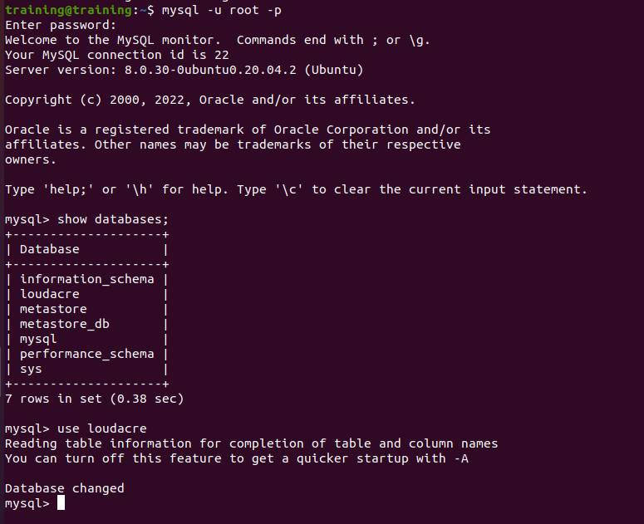

View tables in the loudacre database:  
show tables;

exit;

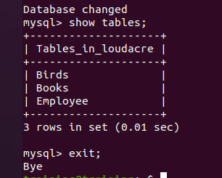

sqoop import \  
--connect jdbc:mysql://localhost/loudacre \  
--username root --password root \  
--table Birds \  
-m 1

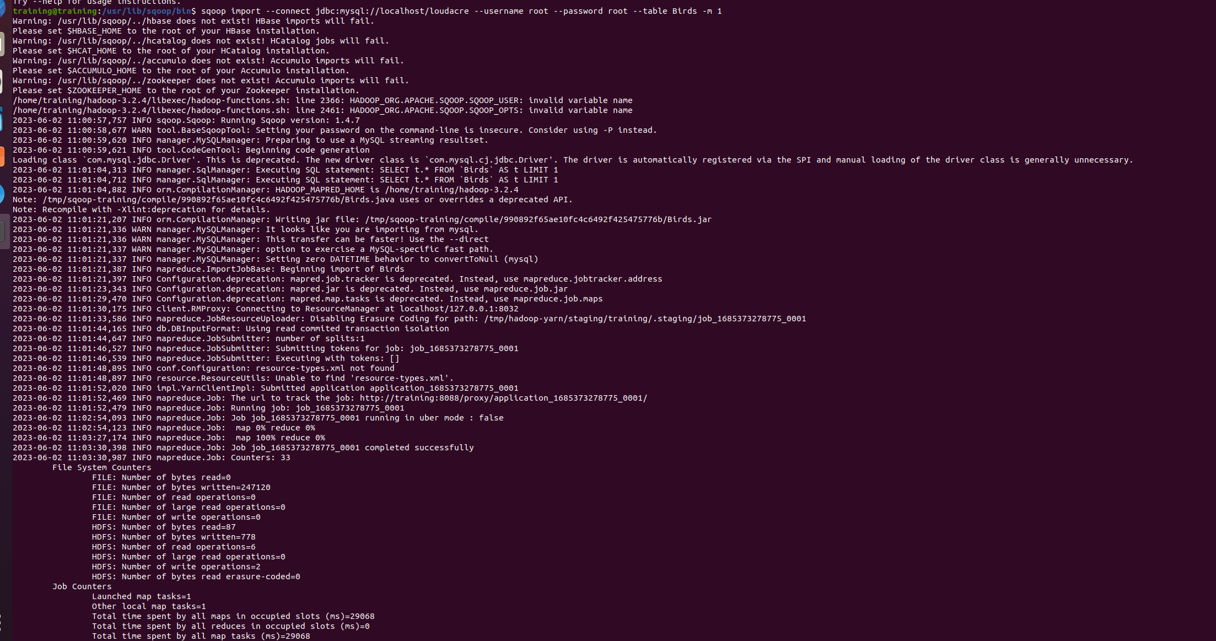

Hdfs dfs –ls

Hdfs dfs –ls Birds

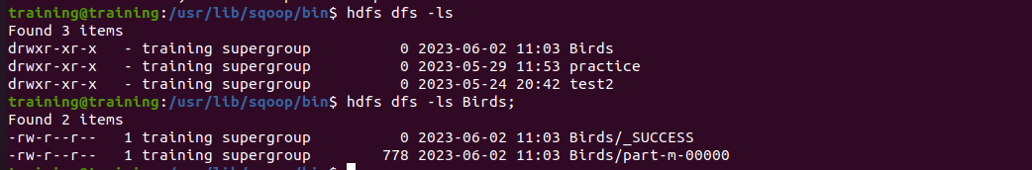  
hdfs dfs -cat Birds/part-m-0000

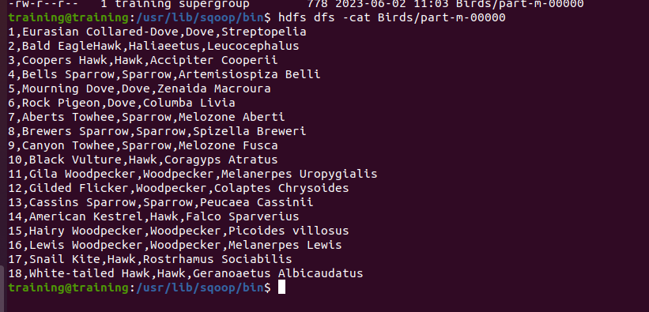

Now import the Birds table to the /loudacre/Birds directory/

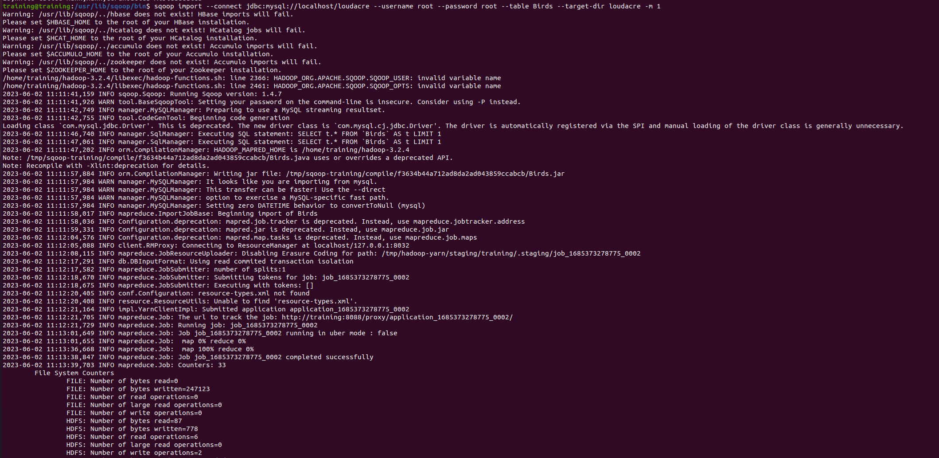

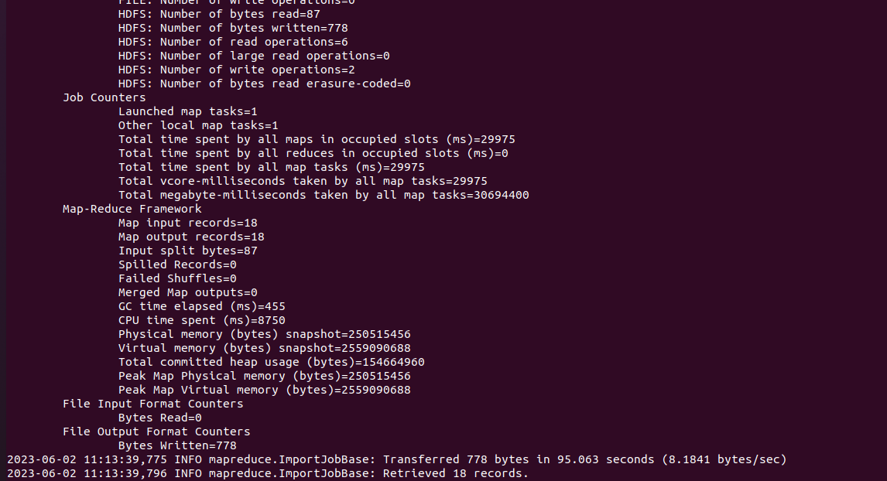

sqoop import-all-tables \  
--connect jdbc:mysql://localhost/loudacre \  
--username root --password root \  
--exclude-tables “Birds” -m 1

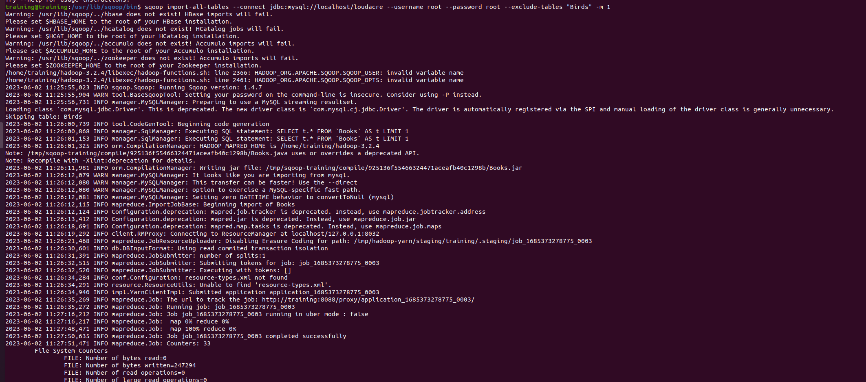

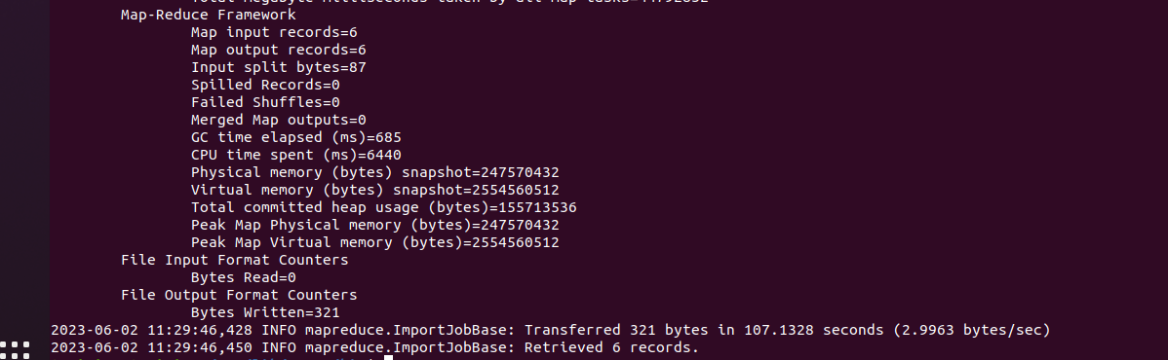

hdfs dfs -rm -r /Birds

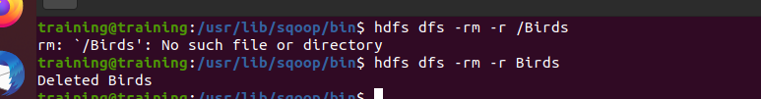

sqoop import -P \  
--connect jdbc:mysql://localhost/loudacre \  
--username root \  
--table Birds \  
--warehouse-dir /loudacre -m 1

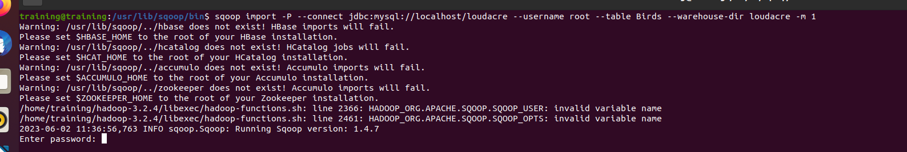

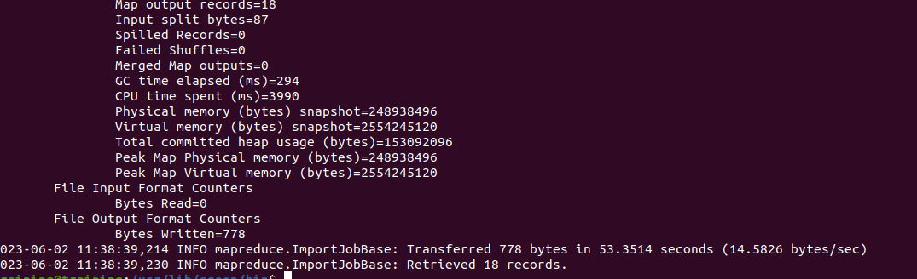

Hdfs dfs –ls /loudacre

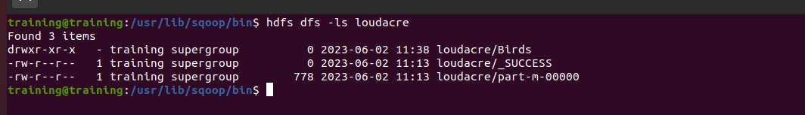

What happens when you run the previous command again? Doesn’t the directory already exist

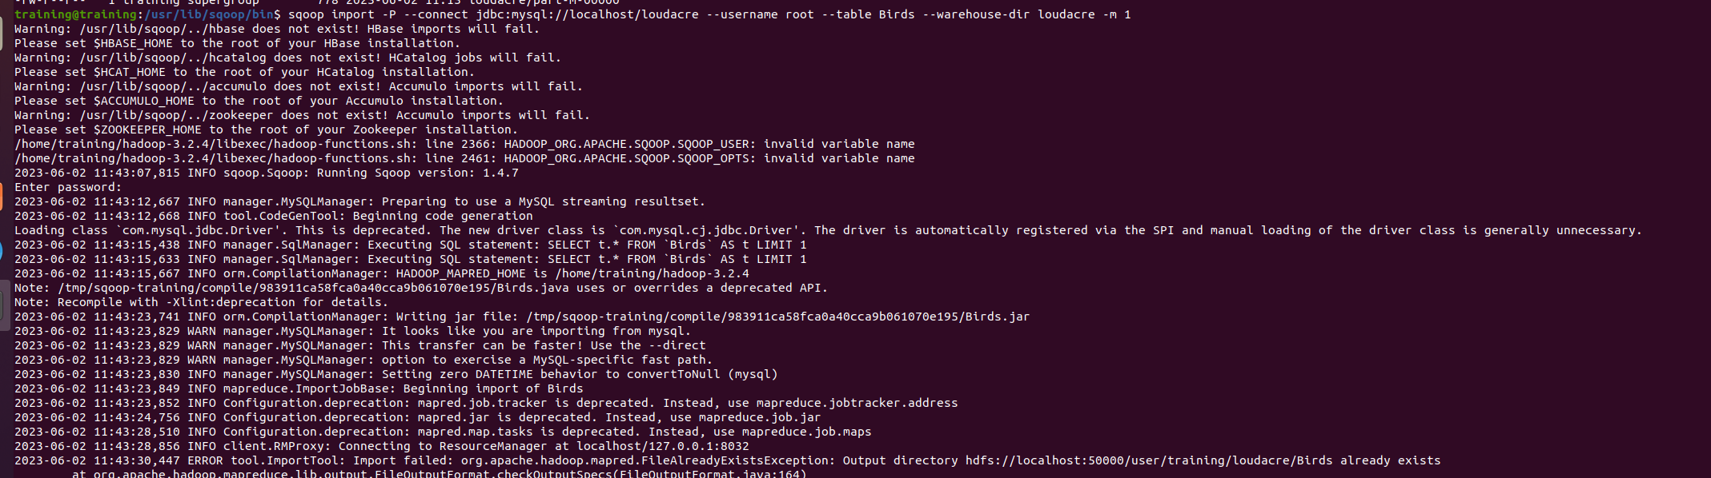

sqoop import -P \  
--connect jdbc:mysql://localhost/loudacre \  
--username root \  
--table Birds \  
--warehouse-dir /loudacre \  
--append -m 1

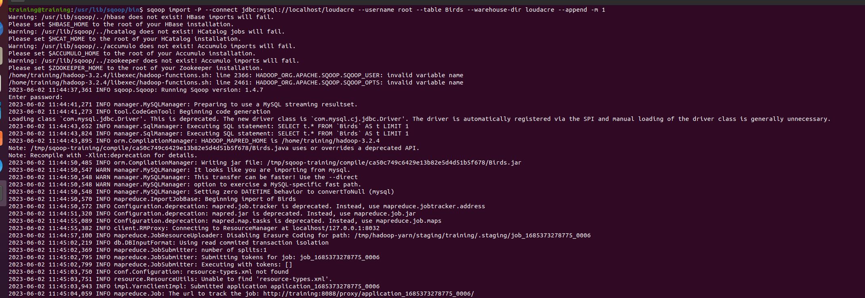

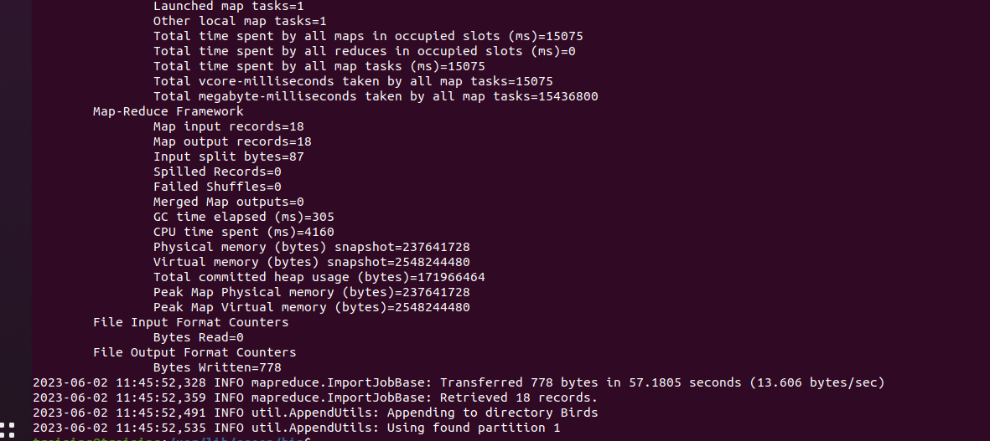

hdfs dfs -rm -r /loudacre/Birds

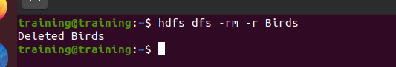

sqoop import -P \  
--connect jdbc:mysql://localhost/loudacre \  
--username root \  
--table Birds \  
--warehouse-dir /loudacre \  
--fields-terminated-by ‘@’

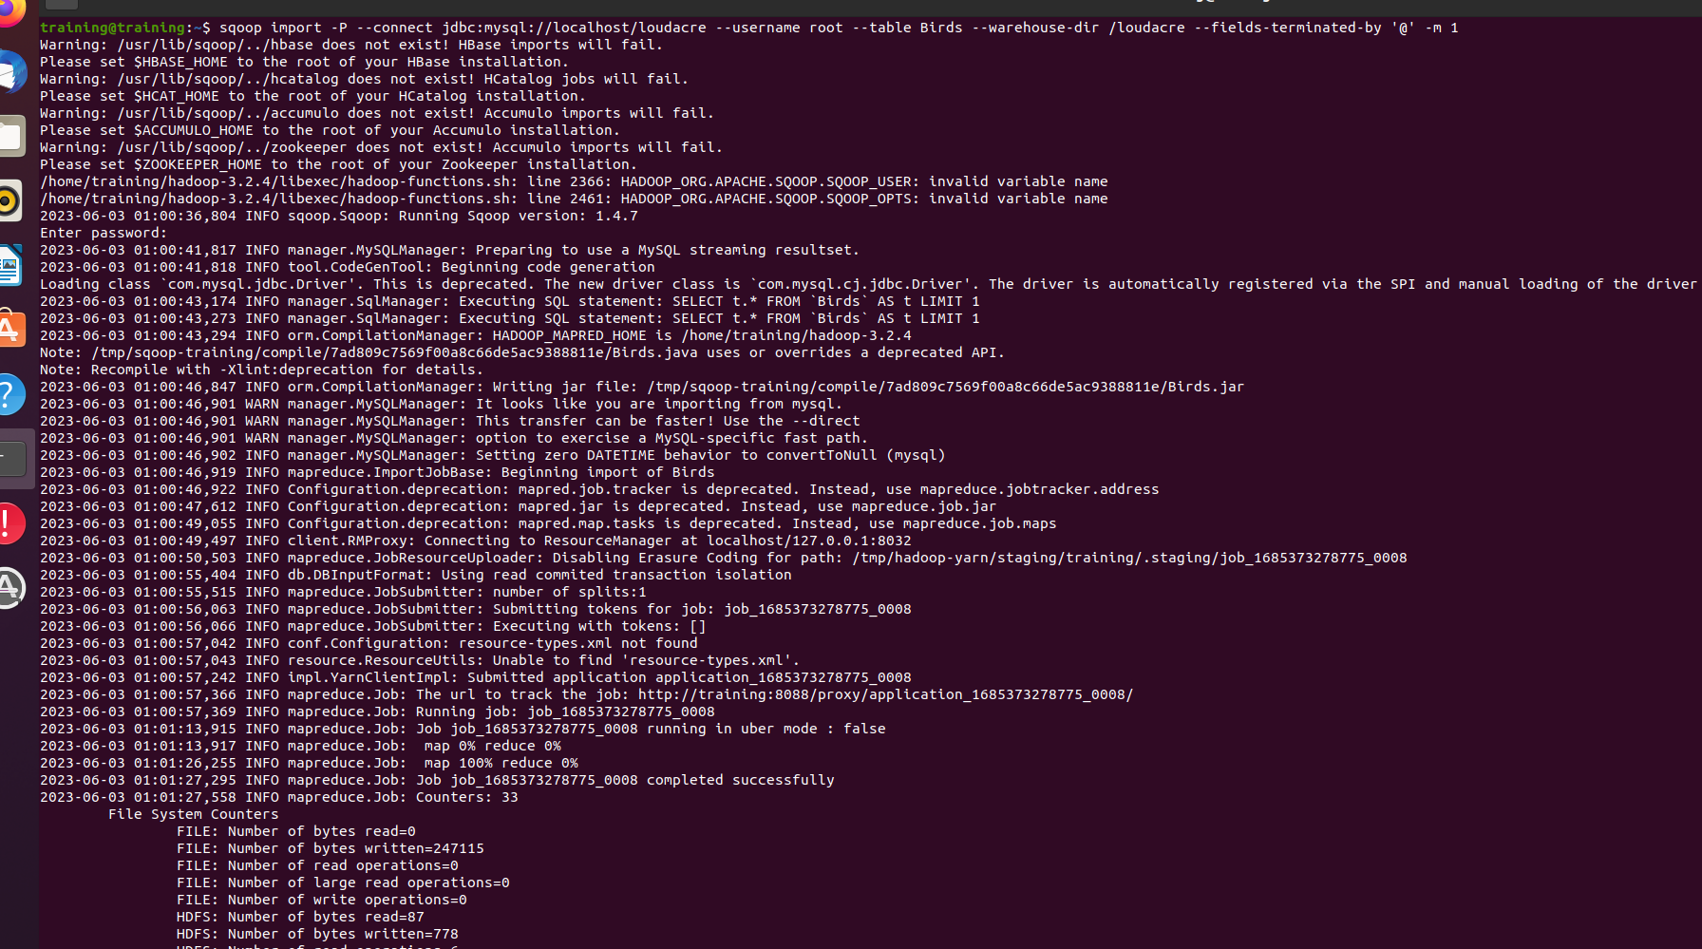

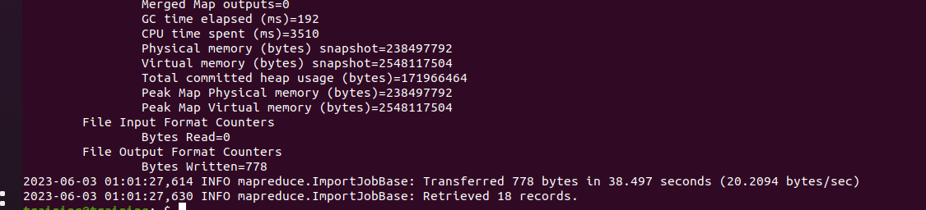

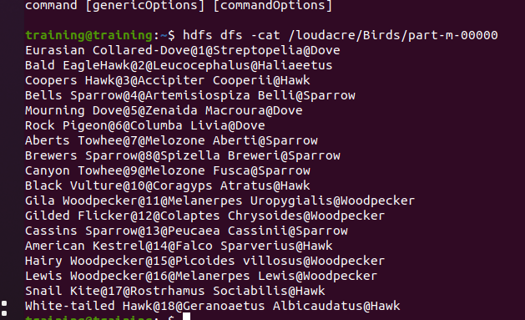

Task: Import Employee table from MySQL to HDFS using ‘#’ as the delimiter.

